INTRODUCTION

GRAN FONDO ISLE OF MAN
Gran Fondo Isle of Man is a major cycling event aimed at all levels of cyclist from elite riders to beginners, families and children.
Gran Fondo Isle of Man evolved from Isle of Man Cyclefest; a wider cycling themed festival which took place successfully for three consecutive years starting in 2016. 2025 will be the final staging of the event in its current format.
In 2019, the organisers of Isle of Man Cyclefest, Isle of Man Cyclefest Ltd, decided not to produce the full festival experience for a range of personal and commercial reasons and ran a successful Gran Fondo event in its place.
Gran Fondo Isle of Man is now organised by Gran Fondo (Isle of Man) Ltd, along with the wider organisational team who have been involved in delivering the event since the outset.
Gran Fondo Isle of Man is scheduled to take place on Saturday the 19th and Sunday the 20th of July 2025, once again based from an Event HQ at Mooragh Park in Ramsey. The event features four individual cycling events:
Gran Fondo – The only true competitive Gran Fondo event staged in the British Isles, held on a largely closed roads 85-mile course.
Medio Fondo – A non-competitive sportive for recreational riders who want to test themselves that little bit further across this 40-mile route.
Piccolo Fondo – A non-competitive sportive aimed at families and beginners, the 20-mile route takes in the coastline and flatter farmland of the Island’s northern plains.
Minisculo Fondo - The family-friendly Minisculo Fondo, held over a half-mile circuit in and around Ramsey’s Mooragh Park is open to children, families and beginners.

ROAD CLOSURES & TRAFFIC RESTRICTIONS
Gran Fondo Isle of Man is an international event and the Island’s premier mass participation sporting occasion.
Gran Fondo (Isle of Man) Ltd will professionally manage the risks to competitors and spectators when delivering this event. It is for that reason that road closures and traffic restrictions are once again requested.
The road closures have been considered in relation to usage and disruption to resident’s normal routine.
There are a number places where road closures could have been applied for but this would mean severe disruption to the residents and gain little for the event. There has been a considered balance between what is needed for the event and what is practical for the Islands population in making these applications.
Formal and informal consultation takes place with a range of stakeholders as part of the course design process. This includes local authorities, regulatory bodies, impacted businesses, sporting associations and clubs and public transport operators.
A public relations blitz with local residents is scheduled to take place in the weeks leading up to the event to minimise the impact the event has to locals and to proactively deal with any issues and/or special arrangements that may be required to be implemented.
The organising team delivering the event and managing the road closures has extensive experience in this regard from events such as the Isle of Man TT Races and Manx Grand Prix as well as nine years' worth of experience delivering extensive road closures across the Isle of Man Cyclefest and Gran Fondo Isle of Man events.
SCHEDULE

Saturday 19th July 2025
1500hrs Minisculo Fondo

Sunday 20th July 2025

0930hrs UCI Gran Fondo
0945hrs Medio Fondo
1000hrs Piccolo Fondo

PARCOURS

MINISCULO FONDO

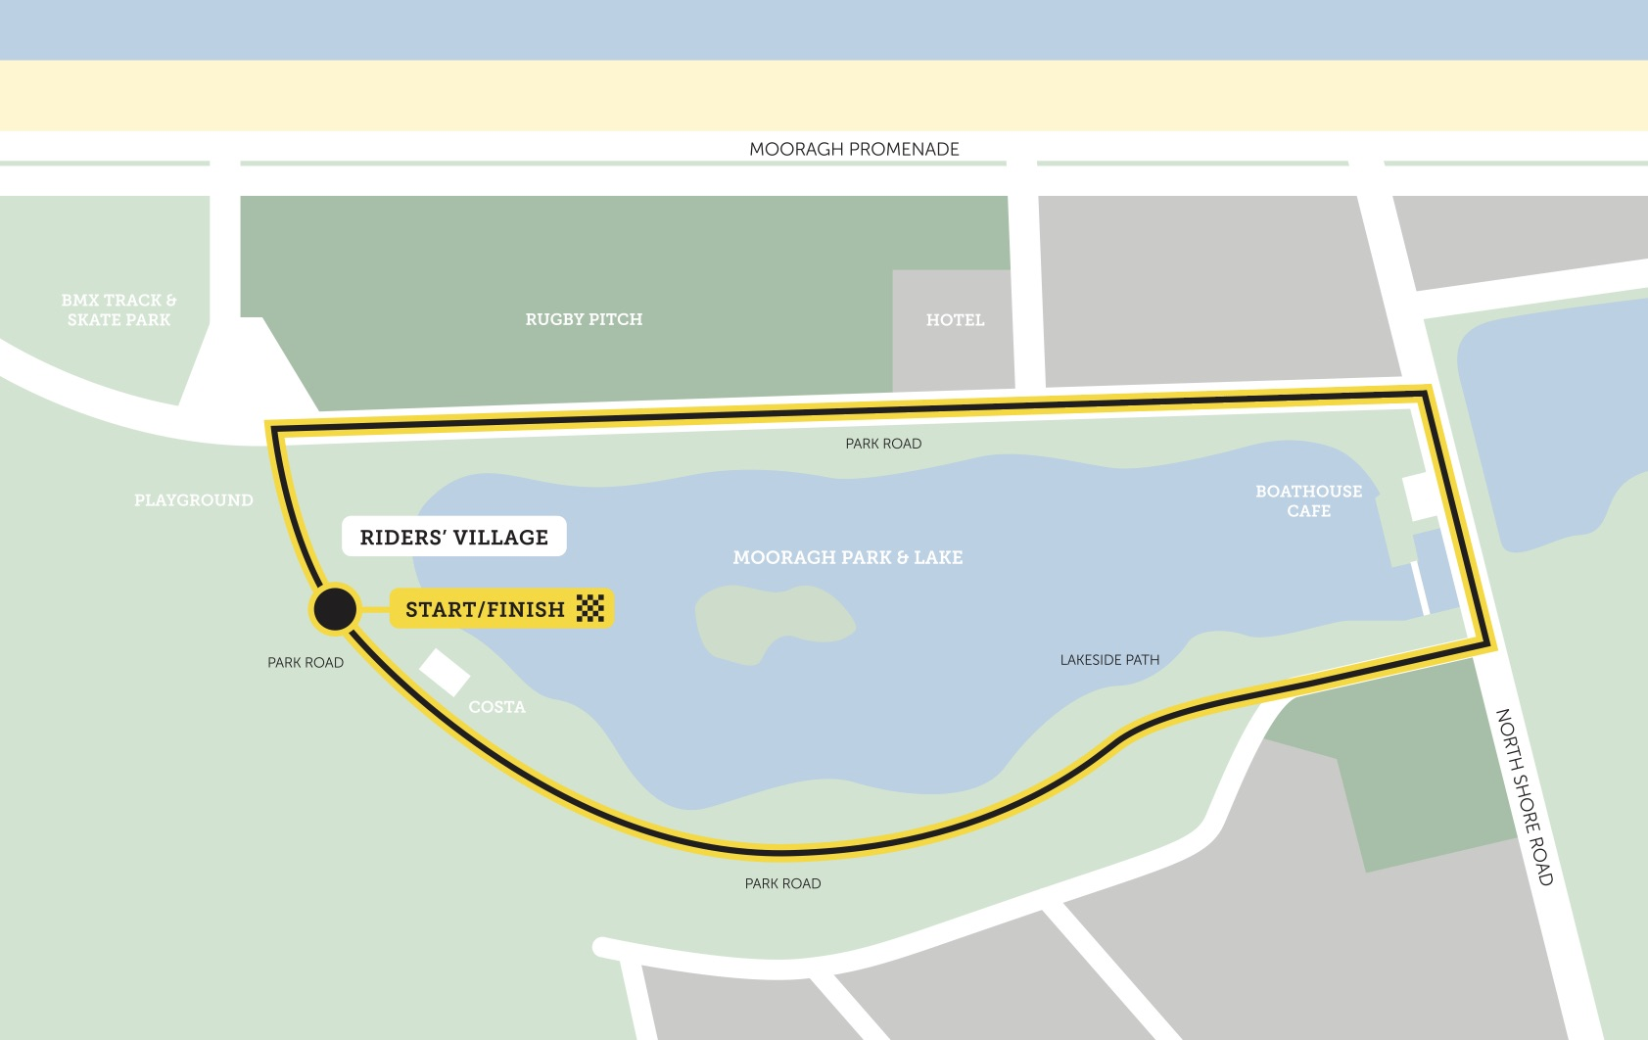
GRAN FONDO
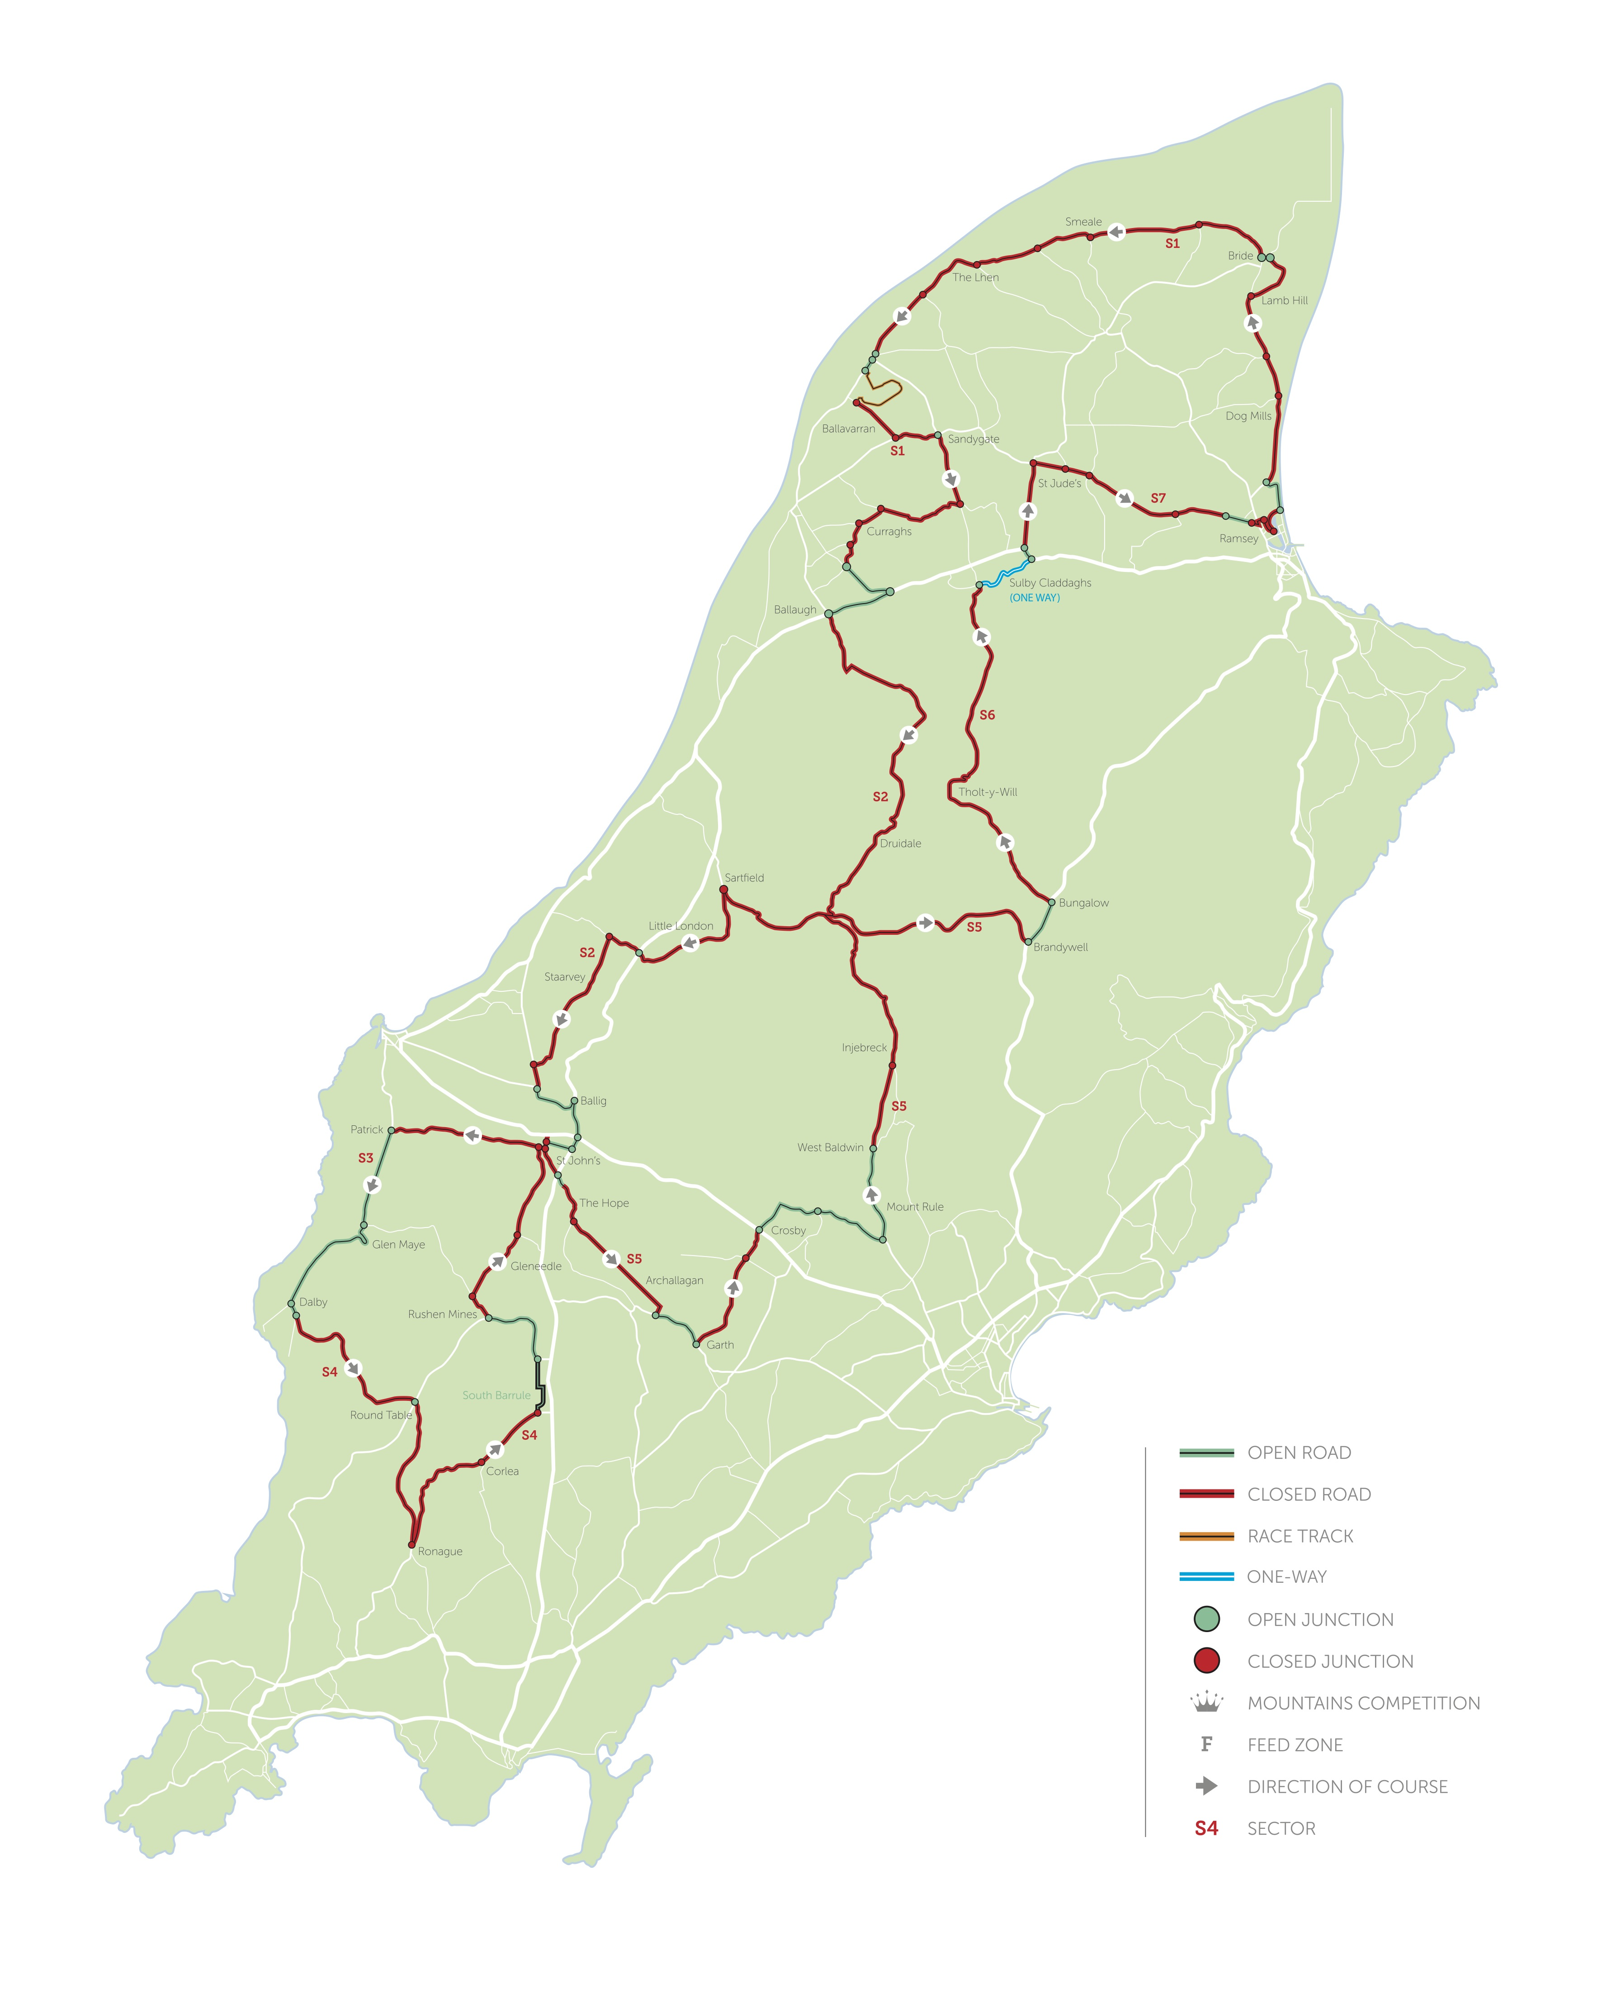
MEDIO FONDO
PICCOLO FONDO
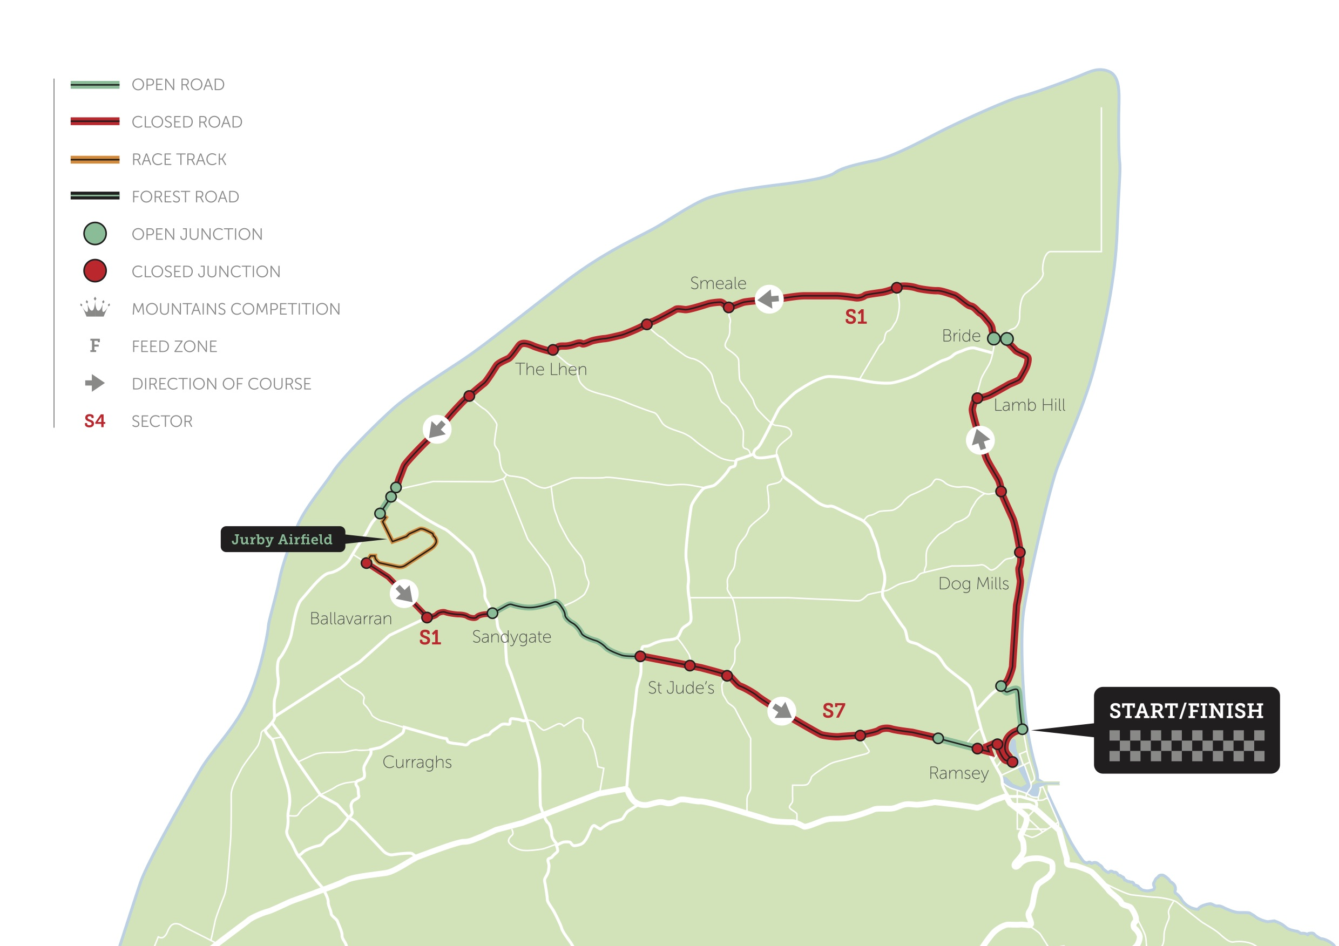

ROAD CLOSURES

MINISCULO FONDO – SATURDAY JULY 19th 2025
Road Closure Time 1430hrs to 1630hrs

- Park Road
- North Shore Road from its junction with Park Road to the junction with Ballacloan Road
- Ballacloan Road

GRAN FONDO | MEDIO FONDO | PICCOLO FONDO – SUNDAY JULY 20th 2025

SECTOR 1
Road Closure Time 0830hrs to 1200hrs
- A10 Bride Road from its junction with Mooragh Promenade to the junction with Lamb Hill.
- Lamb Hill.
- A10 Bride Road from its junction with Cranstal Road to the junction with Bretney Road.
- Ballavarran Road.
- Jurby Road from its junction with Ballavarran Road to the junction with the A14.
- The A14 from its junction with Jurby Road to the junction with Ballaugh Curragh’s.
- The Ballaugh Curragh’s from its junction with the A14 to the junction with Old Windmill Road
- Old Windmill Road from its junction with the Ballaugh Curragh’s to its junction with Dollagh Mooar Road
- The Dollagh Mooar Road from its junction with Old Windmill Road to its junction with Ballaterson Manor.
- Ballaterson Manor.
SECTOR 2
Road Closure Time 0930hrs to 1300hrs
- Glen Road.
- Druidale Road
- Beinney Phott Road (closed till 1600hrs).
- Sartfield Road.
- Little London.

- Ballabooie Road from its junction with the A3 to the junction with Staarvey Road.

- Staarvey Road.
- Switchback Road from its junction with Staarvey Road to the junction with the A20 Poortown Road.

SECTOR 3
Road Closure Time 1000hrs to 1500hrs

- Station Road.
- Patrick Road from its junction with Station Road to the junction with the A27 Dalby Road.

SECTOR 4
Road Closure Time 1000hrs to 1500hrs

- A27 Dalby Road from its junction with Lhagg Road to the junction with the A36 Round Table Road.
- A27 Ronague Road from its junction with the A36 Round Table Road to the junction with Corlea Road.

- Corlea Road from its junction with the Ronague Road to the junction with the west side of South Barrule Plantation.
- Glen Rushen Road from its junction with the A36 Round Table Road to the junction with Slieau Whallian Road.
- Slieau Whallian Road.
SECTOR 5
Road Closure Time 1100hrs to 1600hrs
- Ballavargher Road from its junction with Slieau Whallian Park to the junction with Archallagan Road.
- Archallagan Road.
- Old Church Road.
- West Baldwin road from its junction with Ballamodha Road to Beinn-y-Phott Road

- Beinney Phott Road (closed from 0930hrs).

SECTOR 6
Road Closure Time 1030hrs to 1700hrs

- A14 Tholty Will Road from its junction with the A18 Mountain Road to the junction with the Sulby Claddagh’s
- St Jude’s Road.

SECTOR 6
One Way System Time 1030hrs to 1700hrs
- Sulby Claddaghs (Yn Claddagh) from its junction with the A14 Tholty Will Road to the junction with the A3 Lezayre Road.
SECTOR 7
Road Closure Time 1000hrs to 1700hrs

- A13 Jurby Road from its junction with St Jude’s Road to the junction with Westhill Village.

- A13 Jurby Road from its junction with Ash Grove to the junction with Bowring Road.
- Bowering Road from its junction with Coburg Road and Grove Mount South.
- Cumberland Road
- Windsor Mount Road.

TRAFFIC MANAGEMENT PLAN

MINSICULO FONDO
GRAN FONDO SECTOR 1
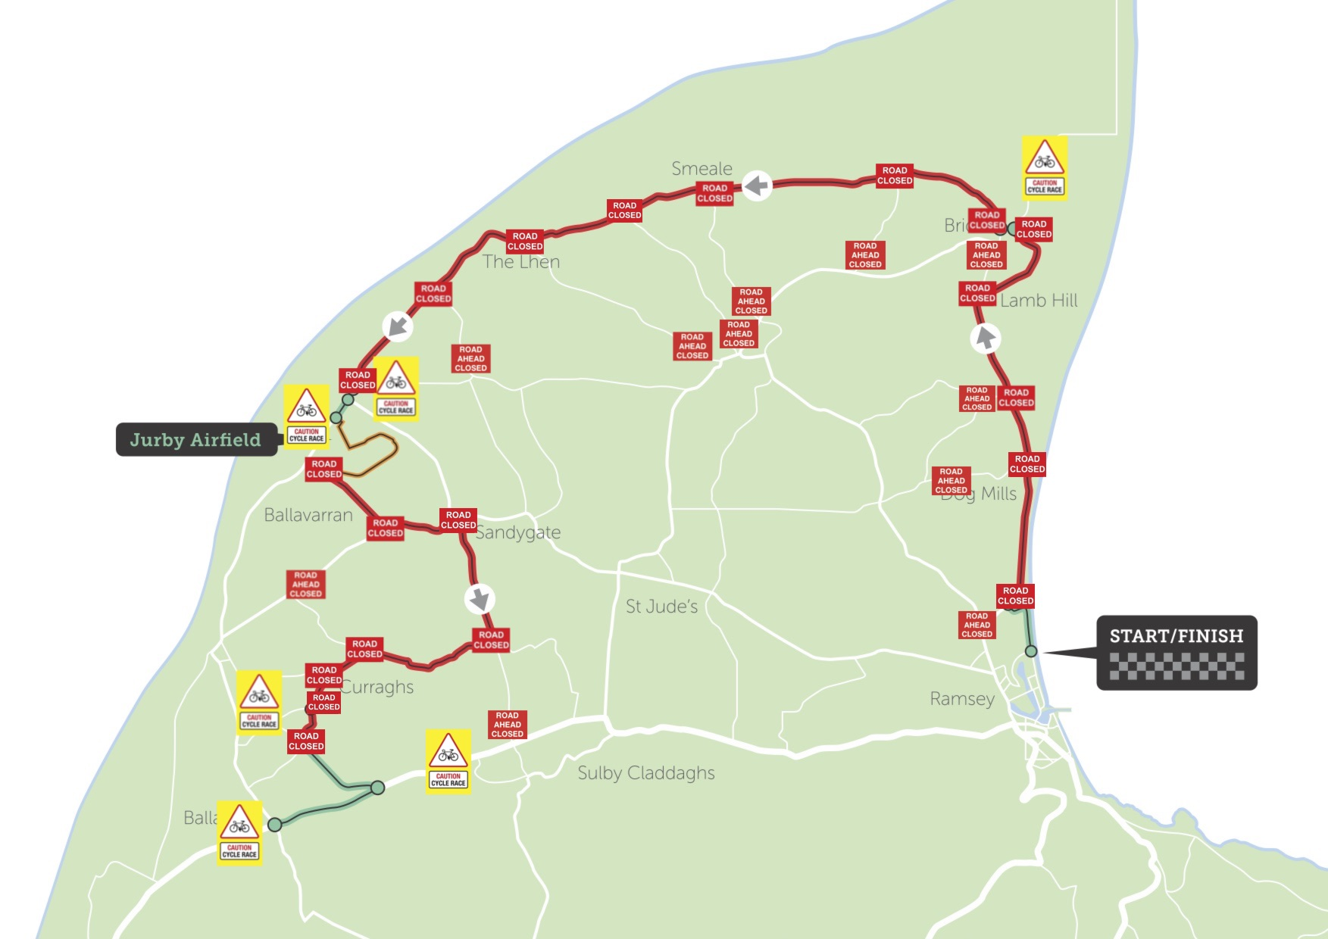
GRAN FONDO SECTOR 2
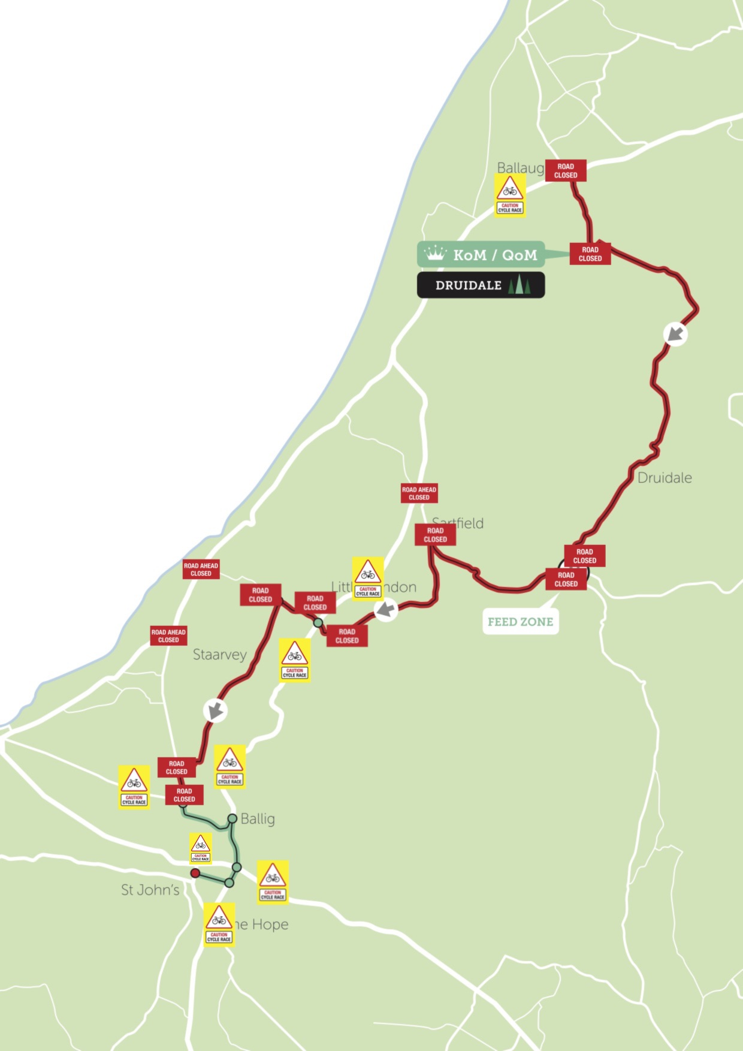
GRAN FONDO SECTOR 3
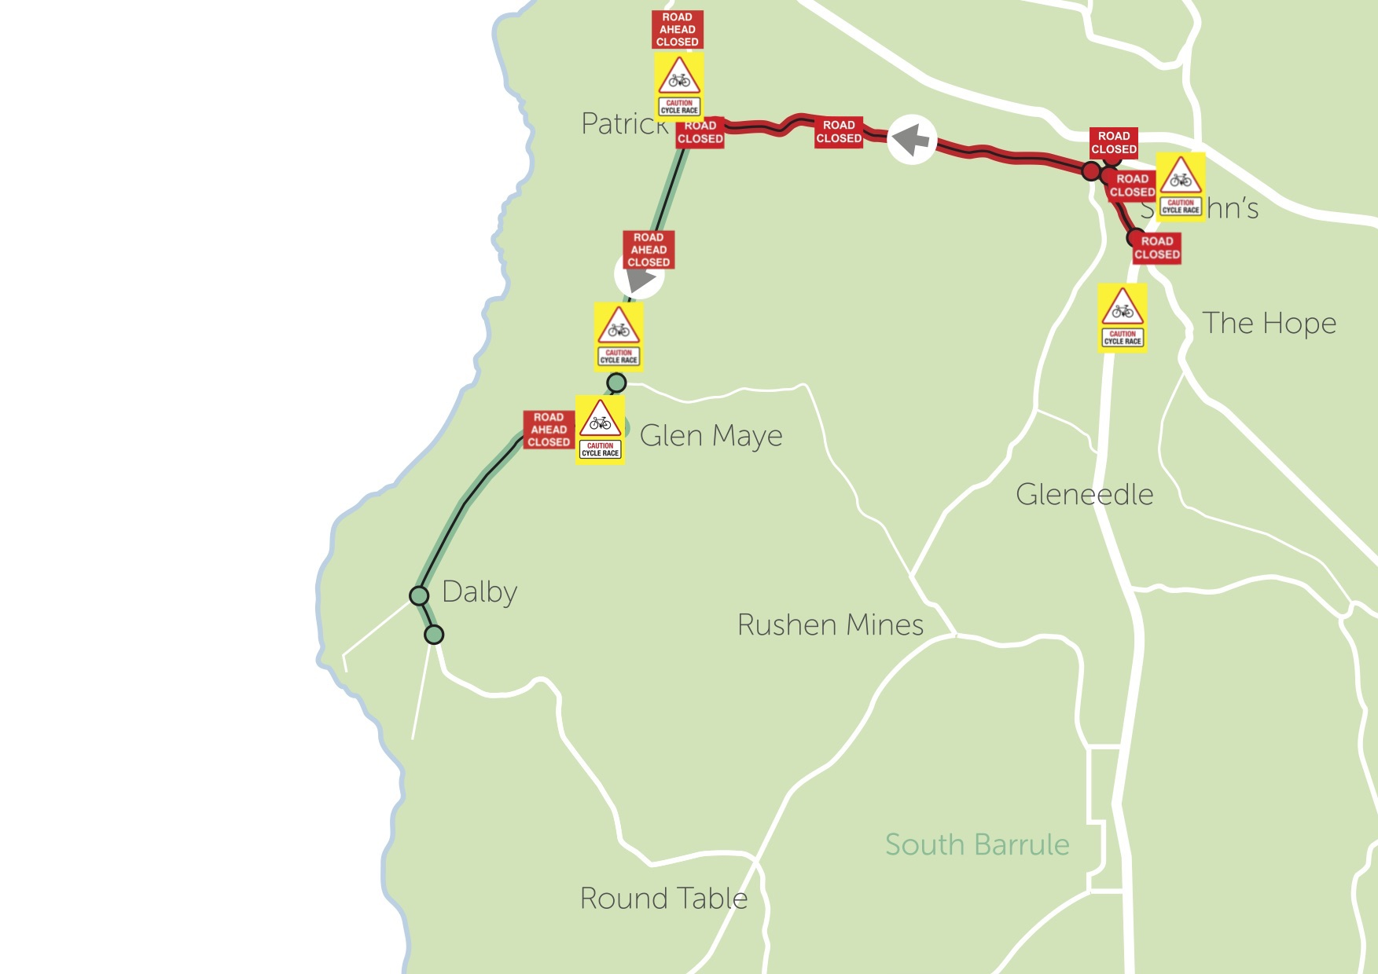
GRAN FONDO SECTOR 4
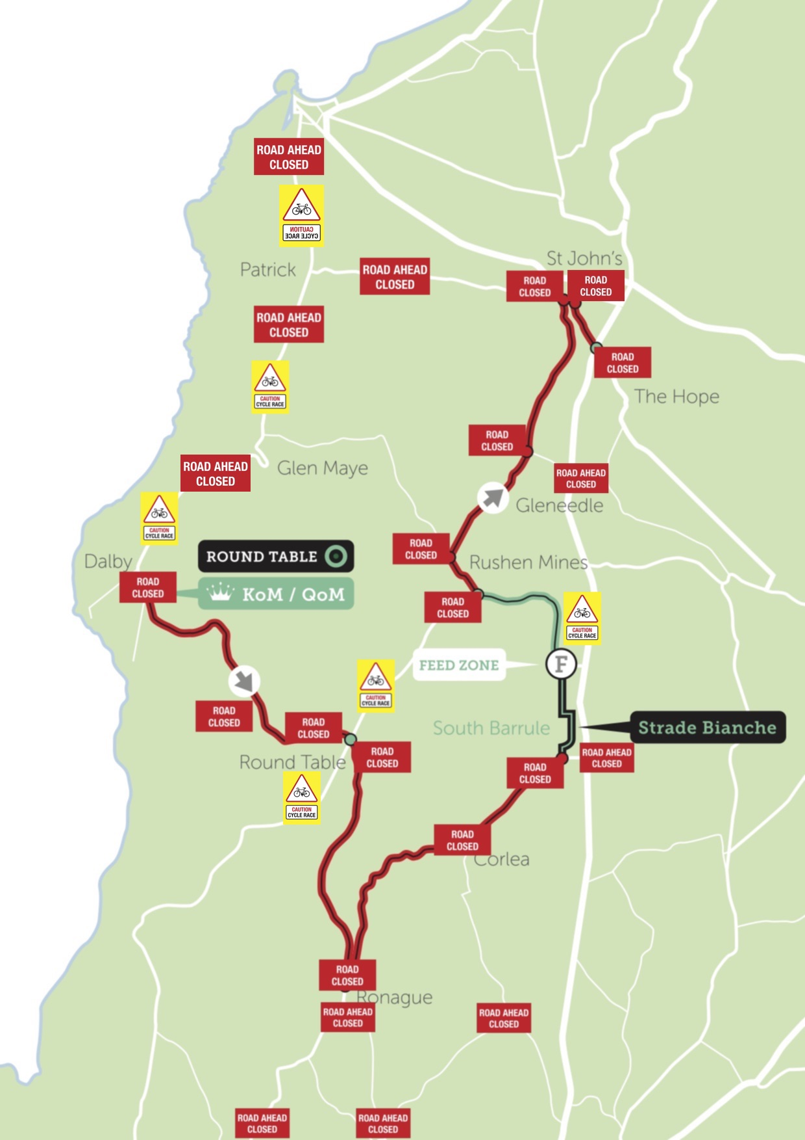
GRAN FONDO SECTOR 5
GRAN FONDO SECTOR 6
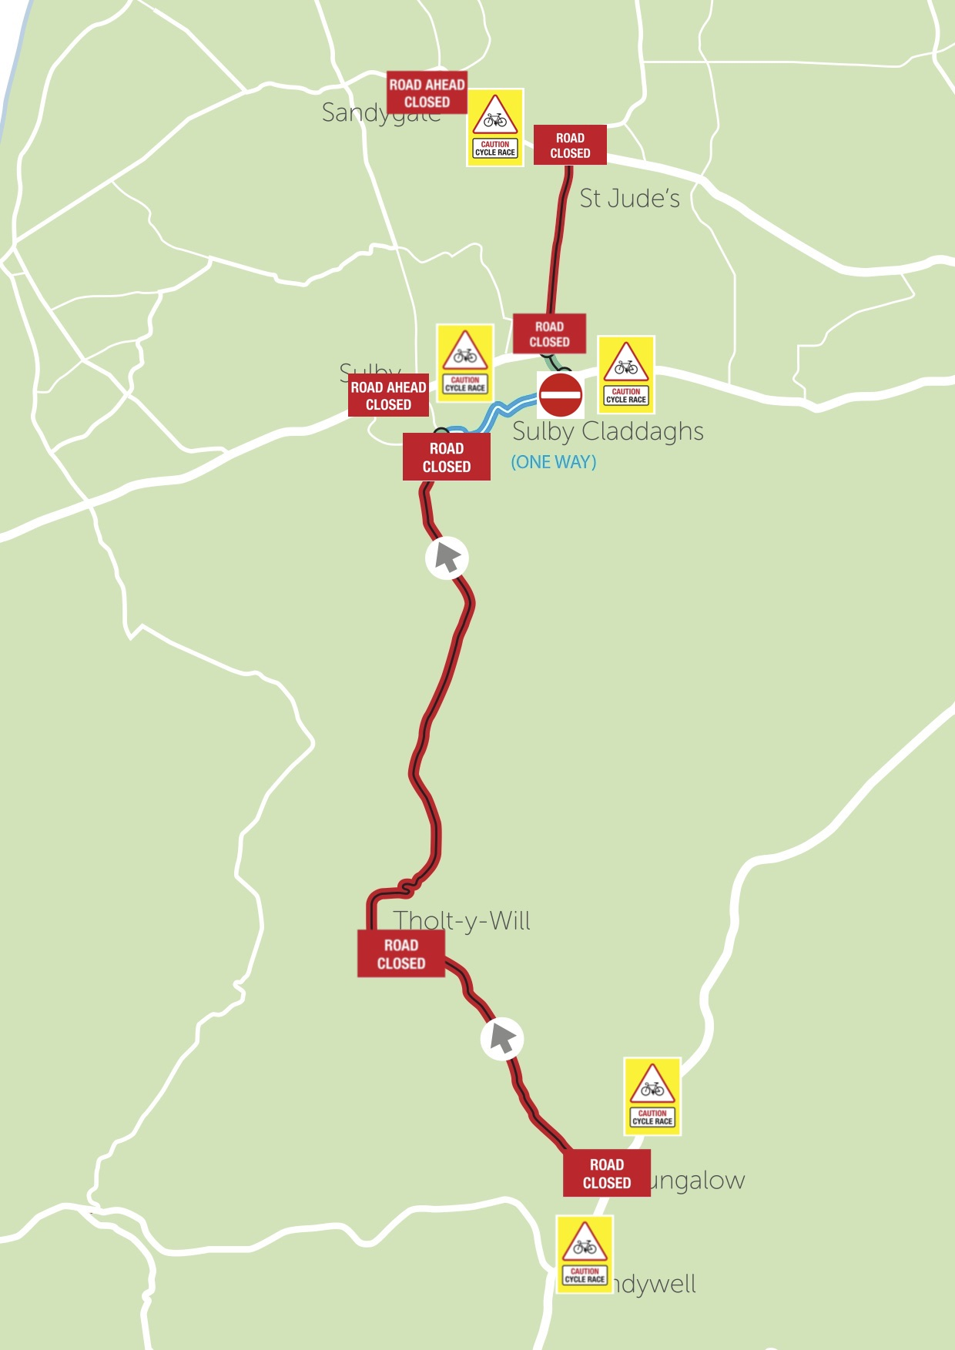
GRAN FONDO SECTOR 6 (SULBY CLADDAGHS 1 WAY SYSTEM)

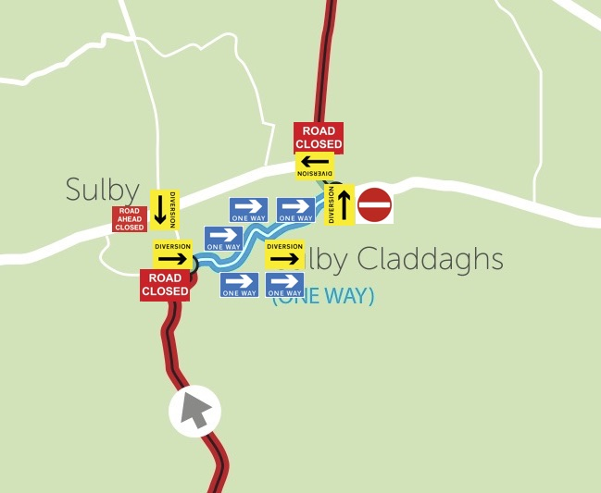
GRAN FONDO SECTOR 7
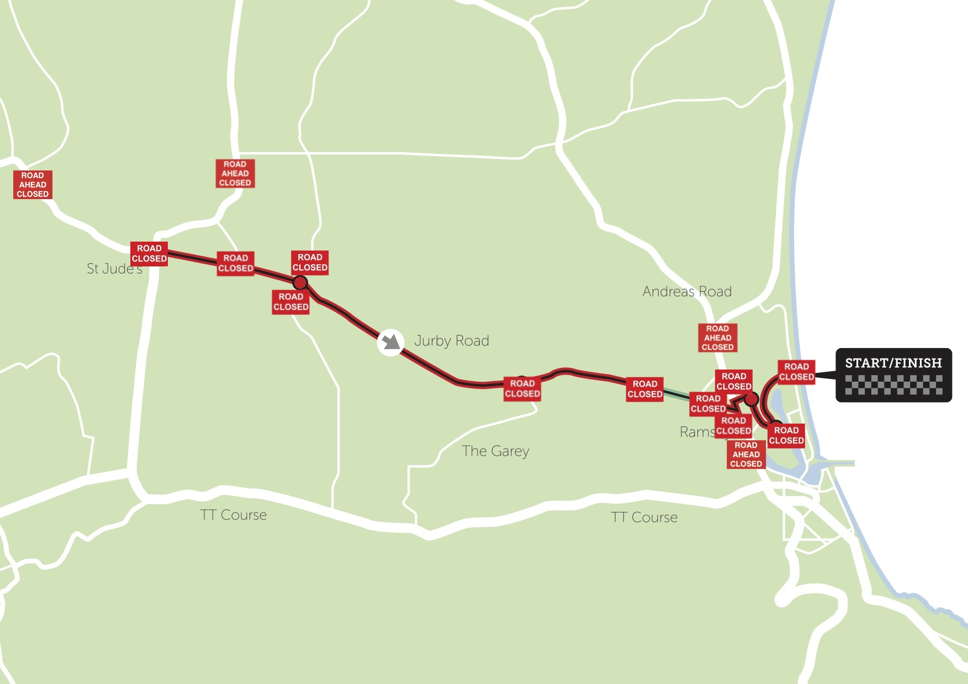
GRAN FONDO SECTOR 7 (BOWRING ROAD DIVERSION)

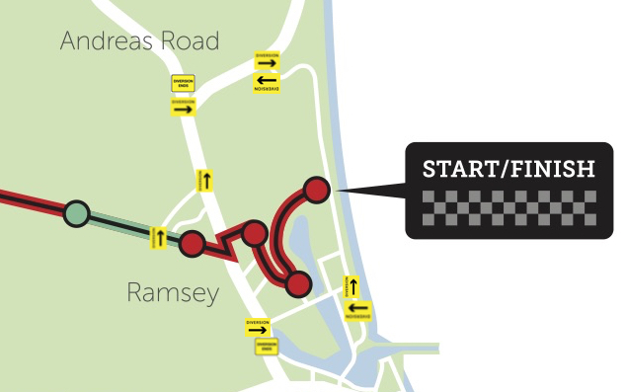

RISK ASSESMENT

Gran Fondo Isle of Man comprises five organised cycle events on Saturday 19th and Sunday 20th July 2025.
The events are graded for different levels of cycling ability from children and beginners to professional cyclists.
 | Individual Time Trial  Minisculo Fondo | Beginners, children and accompanying adult cyclists ride a track around the Mooragh Park
 | Gran Fondo  Medio Fondo | Experienced regular cyclists – mix of competitive and recreational riding a challenging 85 Mile course  Experienced and intermediate cyclists ride a 40 Mile course
 | Piccolo Fondo | Intermediate and casual cyclists ride a 20 Mile course
Hazard | Who | Impact | Risk Rating | Control Measures | Residual Risk
General Traffic | Riders | Collision / injury | HIGH | Close Road where practical to maintain separation of riders from traffic | MED
 | Competitors |  | HIGH | Course inspection vehicle to check route ahead of cyclists | MED
 | Setup Team |  | HIGH | Set-up / break-down teams to wear hi-vis clothing when out of vehicle | MED
 | Marshals |  | HIGH | Vehicle to use hazards warning lights when stopping for setup/breakdown | MED
 | Travelling marshals |  | HIGH | Adequate event signage and support vehicle labelling | MED
Junctions
Type A with private access route | All as above | Collision / injury | MED | Mail drop; Direct communication with residents; Course inspection; Road closed signs only if required. | LOW
Type B with low use road / green lane | All as above | Collision / injury | MED | Road closed sign only | LOW
Type C with medium use road | All as above | Collision / injury | MED | Road closed sign with attending marshal(s) as required | LOW
Type D with high use or high speed road | All as above | Collision / injury | HIGH | Road closed sign with marshal(s); travelling marshal to assist as necessary | LOW
Type E open road with traffic flow | All as above | Collision / injury | HIGH | Marshal(s) with travelling marshal as necessary | MED
Type F open road crossing traffic flow | All as above | Collision / injury | HIGH | Marshal(s) with police assistance and /or travelling marshal as necessary | MED
Pedestrians within Mooragh Park | Riders/competitors and pedestrians | Collision / injury | HIGH | Barriers as necessary; Marshal(s) with audible warning devices attending crossing points | MED
Emergency response vehicle access | All as above | Collision / injury | MED | Race control will be in contact with control room and with support vehicles and Travelling Marshals via the digital radio system to warn and co-ordinate for any emergency vehicles, which have to enter the closed roads. | LOW
Route goes from closed to open road | All as above | Collision / injury | HIGH | Signage, marshals, travelling marshals and police as required | LOW
Vehicle follows riders from open to closed roads | All as above | Collision / injury | MED | Signage, marshals, travelling marshals and police as required | LOW
Adverse Weather | All as above | Loss of visibility leading to collision / injury | HIGH | Commissaires to advise on viability of route during event | MED
Riders going off route | Riders/Competitors | Riders potentially unsafe | HIGH | Rider briefings, support vehicle communications and transponder sector tracking | LOW
Road surface faults | All as above | Crash / injury | HIGH | Request to DoI Highway Services to patch and pre-sweep route. Warning signs for riders | MED
Slow riders | Riders/Competitors | Closure finishes and rider proceeds on open roads | MED | Communications through rider information packs, rider briefings, and road open vehicle to notify any riders it overtakes | LOW
Retirements from event | Riders/Competitors | Rider unaccounted for | MED | Rider briefings, support vehicle communications and contact number at race control | LOW
General Injuries | All as above | As hazard | MED | First aid and paramedic support | LOW
‘Problem’ junctions (Crosby, St Johns, Garth) | Riders/Competitors | Crash / Injury | MED | Increased signage and increased marshals and stewards to be deployed. | LOW
Participant crashes | Riders | Injury | HIGH | MRMS engaged to provide robust medical response built from previous learning’s on event. Controlled and managed from central Race Control with direct links to IOM NHS. | MED
Weather | Riders | Crash / Injury | HIGH | Riders advised of consequences of extreme weather in days before event and at pre-race briefing. Broom wagon to follow the race at the back of the convoy to pick up riders who may be affected by adverse weather and will have suitable clothing made available. All personnel assisting with the event to be advised in advance of the predicted weather forecast and advised to be dressed appropriately | MED
Fatigue/dehydration | Riders/Competitors | Crash / injury | MED | Provide feeding stations and water pick-up points | LOW

KEY CONTACTS / INFORMATION

Event Director Paul Phillips 07624480451 paulphillips@manx.net
Clerk of Course Lizzie Kinvig 07624298608 lizziekinvig@gmail.com

Web Site granfondoisleofman.com

Facebook facebook.com/granfondoiom

Instagram www.instagram.com/granfondoiom

VERSION 1 | Jan 27 2025

